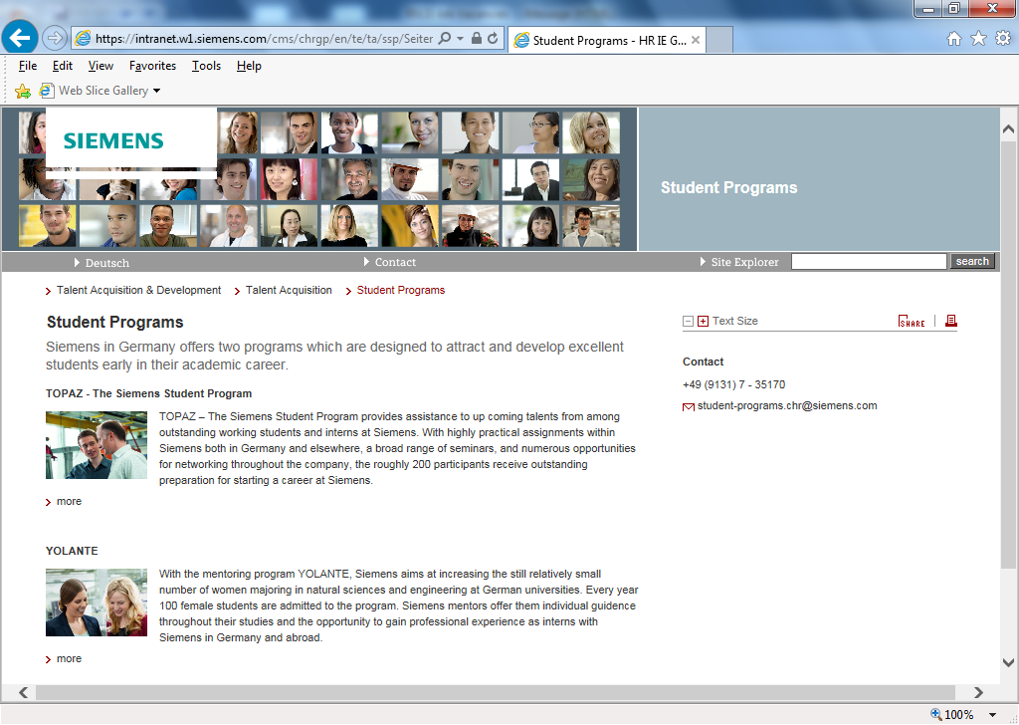
Position: Associate Firmware Engineer
职位名称：助理嵌入式软件工程师
Job requirements
1.2016 graduates. Master degree major in computer science, automation, electronics or related
2016年应届硕士毕业生，计算机、自动化或电子类等相关专业
2.Familiar with C, C++, Assembly language.
熟悉C,C++和汇编语言
3.Have the experience of developing device driver (UART, LCD, IO etc) on single chip MCU or ARM based device.
具有在单片机或者ARM设备驱动开发经验
4.Understand and familiar with data structure and basic communication protocol. Eg: Modbus, TCP/IP, CAN
理解和熟悉数据结构以及基本的通信协议，例如Modbus, TCP/IP, CAN

Job responsibilities
1. Design, implement and test embedded software modules with other engineer's help to accomplish project on time with high quality.
在其他工程师的帮助下完成软件设计、实现和测试嵌入式软件模块，保证软件满足需求、项目按期高质量完成
2. Debug and integrate software modules; solve problems of integration to make software stable and reliable.
调试和集成软件模块，解决集成中发现的问题，保证软件运行稳定可靠
3. Execute unified software development process and raise proposals for improvement;
执行统一的软件开发流程，提出改进意见和建议， 保障流程得以贯彻和执行
4. Cooperate with colleagues and create a good working atmosphere together.
与其他同事很好地协作和配合，共同创建良好的工作氛围
5.Support other activities in firmware & software dept., thereby the whole dept. can run well.
支持软件部门的其它活动，协助软件部门良好运行

公司介绍
北京西门子西伯乐斯电子有限公司成立于1995年，是西门子楼宇科技集团在中国唯一的研发与生产基地，现已发展成为西门子楼宇科技集团在全球最重要的研发与制造中心。公司自成立以来，始终立志成为亚太地区消防、安防、暖通空调产品的市场领导者，长期专注于为中国客户研发、设计、生产和销售高性能的消防及安防电子产品、暖通空调产品等，以及提供相关的专业技术服务。产品远销东南亚以及拉丁美洲近30多个国家和地区。我们期待着您的加盟，共同实现目标。在这里，您会体验到国际化的工作环境，拥有卓越的职业发展机会。

Established in 1995, Beijing Siemens Cerberus Electronics Ltd. (BSCE) is the only R&D and manufacturing center of Siemens Building Technology Group in China. Now it has become the most important part of Siemens Building Technology. Since its establishment, BSCE has always been determining to become the market leader of the products manufacturing in the fire safety, security, HVAC in the Asia-Pacific region. And also it focuses on R&D, manufacturing and selling high-performance electronic fire-fighting and security products, HVAC products, etc, and providing relevant professionally technical services. Its products are exported to nearly 30 countries in Southeast Asia and Latin America. We look forward to your joining to help us realize our objectives; you will get excellent opportunities for individual career development and experience a multinational working environment.

